**THE MODEL INSTITUTE OF ENGINEERING AND TECHNOLOGY (Autonomous)**

**Kot Bhalwal, Jammu**

**SYNOPSIS**

**SIGN LANGUAGE CONVERSION**

Submitted in partial fulfilment of the requirement for the award of the Degree of

Masters of Computer Applications

SESSION: 2022-2024

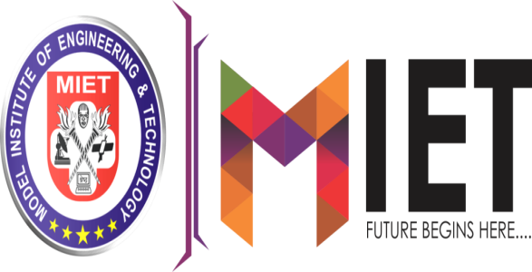

**SUBMITTED BY**

Divyansh Gupta (2022d1r015)

Aniket Sharma (2022d1r013)

M.CA - IVTH SEM

**UNDER THE GUIDANCE OF**

Mr. Vishal Gupta

(Head M.C.A Department)

**TABLE OF CONTENT**

1. Title Of The Project.............................................................1
2. Hardware And Software Requirements...............................2
3. Introduction..........................................................................3
4. Abstract................................................................................4
5. About SLC...........................................................................5

5.1 Uses Of SLC...…….......................................................5

1. Working Of SLC………………..........................................6
2. Steps Involved For SLC System...........................................7
3. METHODOLOGY...............................................................8
4. Flowchart Of SVM...............................................................9
5. Pictorial Representation.......................................................10

**SYNOPSIS**

**TITLE OF THE PROJECT:**

**SIGN LANGUAGE CONVERSION**

**(****SLC)**

**HARDWARE REQUIREMENTS**

* **Processor:** AMD or Intel Core i3 or higher
* **Ram:** 4GB or higher
* **Camera or webcam:** Capable of capturing live video feed
* **Speakers or headphones:** For audio output

**SOFTWARE REQUIREMENTS**

* **Operating System:** Windows OS 8 or above
* **IDE:**  Anaconda IDE or Visual Studio Code
* **Machine Learning Library:** OpenCV, TensorFlow, Kera’s, NumPy
* **Language:**  Python

**INTRODUCTION**

Technology helps to improve different complex task in our daily life, even for decision making, market, monitoring and surveillance are now in these days becomes automated. In addition of that the machine learning and object recognition techniques are also provides help in different real world applications. The proposed work is focused on study of pattern matching and recognition techniques therefore an application of this domain is targeted for design and development. In this presented work the technique of image processing and character recognition is used for designing and developing the automatic number plate recognition. The proposed technique help to identify the number plate and extract the accurate characters from the target number plate. The number plate recognition is an image processing technique to extract the image of license plate on vehicle taken by digital camera or taken by either a colour or a grayscale digital camera, as well as an infrared camera in order to identify the vehicles using their numberplate.

The Number Plate Recognition system recognizes characters on license plate through the combination of various techniques and algorithms, including **image pre-processing, object detection, character segmentation and recognition**. It consists of a camera to detect the number plate object and processing unit to process and extract the characters and interpret the pixels into numerically readable characters. The ANPR system has been used in traffic law enforcement, including speed camera, traffic light camera, stolen car detection, border monitoring and can be implemented on the entrance for security control of a highly restricted area such as an organization. It can be used also for the building management, such as parking management and gate control.

Machine learning approaches the problem in a different way. The idea is to take a large number of number plates, known as training data and then develop a system which can learn from those training examples. In other words, the machine learning uses the examples to automatically infer rules for recognizing number plate. Furthermore, by increasing the number of training examples, the network can learn more about numbers and characters, and so improve its accuracy.

**ABSRACT**

Sign language is one of the oldest and most natural form of language for communication, hence we have come up with a real time method using neural networks for finger spelling based American sign language. Automatic human gesture recognition from camera images is an interesting topic for developing vision. We propose a convolution neural network (CNN) method to recognize hand gestures of human actions from a image captured by camera. The purpose is to recognize hand gestures of human task activities from a camera image. The skin model, position of hand and orientation are applied to obtain the training and testing data for the CNN. The hand is first passed through a filter and after the filter is applied where the hand is passed through a classifier which predicts the class of the hand gestures. The hand position aims at translating and rotating the hand image to a neutral pose. Then the calibrated images are used to train the CNN.

This project contains two main parts: - **Detection and Recognition**. The developed system first detects the vehicle and then captures the vehicle image. Vehicle number plate region is then converted into grayscale. The number plate is then extracted. Then, various algorithm are used to recognize the digits and the alphabets. This data can be used to find vehicle’s owner, place of registration, address, and most importantly note down the incoming and outgoing time .The system is implemented by using **the OpenCV library** along with python and its performance is tested on real images. It is observed from the experiment that the developed system successfully detects and recognize the vehicle number plate on real images. After the completion of the above-mentioned steps, now the process of segmentation is being applied to detect the text present on number plate by making use of matching of template and **OCR.** This system is able to detect the license number accurately as well as quickly from the vehicle’s picture.

**Key Words:-** Machine Learning, Image Processing, CNN model, Gaussian blur filter, Threshold filter Grayscale, OpenCV, Python.

**ABOUT SLC**

"Sign Language Conversion" is an innovative application of Human-Computer Interaction and Machine Learning technologies. It aims to bridge the communication gap between the hearing-impaired community and those who may not understand sign language. This system is designed to recognize and interpret sign language gestures, converting them into written text. But it doesn't stop there. To make communication even more seamless, the system also includes a feature to convert this text into audio output. This allows individuals who are visually impaired or prefer auditory communication to understand the message as well.

**USES OF SLC**

1. **Accessibility in Public Spaces:** Public places such as libraries, banks, hospitals, and government offices can integrate the system to provide accessible communication options for individuals with hearing impairments, ensuring they can access services independently.
2. **Education and Learning:** Educational institutions can utilize the system to facilitate communication between students who are deaf or hard of hearing and their peers, teachers, and support staff.
3. **Emergency Response and Public Safety:** Emergency response services can benefit from the system by enabling communication with individuals who are deaf or hard of hearing during emergencies or crisis situations, ensuring they receive timely information and assistance.
4. **Remote Communication:** The system can be utilized for remote communication, enabling individuals who are deaf or hard of hearing to participate in virtual meetings, conferences, and online interactions with real-time sign language interpretation and audio output.

**WORKING OF SLC**

1. **Image Acquisition:** The system captures live video feed or images containing sign language gestures using a camera or webcam.
2. **Gesture** **Detection:** The captured images or video frames are processed using computer vision techniques, such as object detection and segmentation. This step focuses on detecting and isolating sign language gestures from the background.
3. **Gesture Recognition:** Utilizing machine learning algorithms, particularly convolutional neural networks (CNNs) or other models trained on sign language datasets, the system recognizes and interprets the detected gestures. This involves mapping each gesture to its corresponding meaning or textual representation.
4. **Text Generation:** Once the gestures are recognized, the system converts them into written text using natural language processing (NLP) algorithms. This step involves encoding the recognized gestures into textual transcriptions, representing the spoken words associated with the sign language gestures.
5. **Audio Synthesis:** In addition to textual output, the system synthesizes audio representations of the recognized words using speech synthesis techniques. This allows for auditory communication of the interpreted sign language gestures, enhancing accessibility for individuals who are visually impaired or prefer auditory communication.
6. **Output Display:** The system may display the textual transcriptions alongside the captured video feed, providing real-time feedback of the interpreted sign language gestures. Additionally, the synthesized audio may be played back through speakers or headphones, enabling users to hear the communicated message.

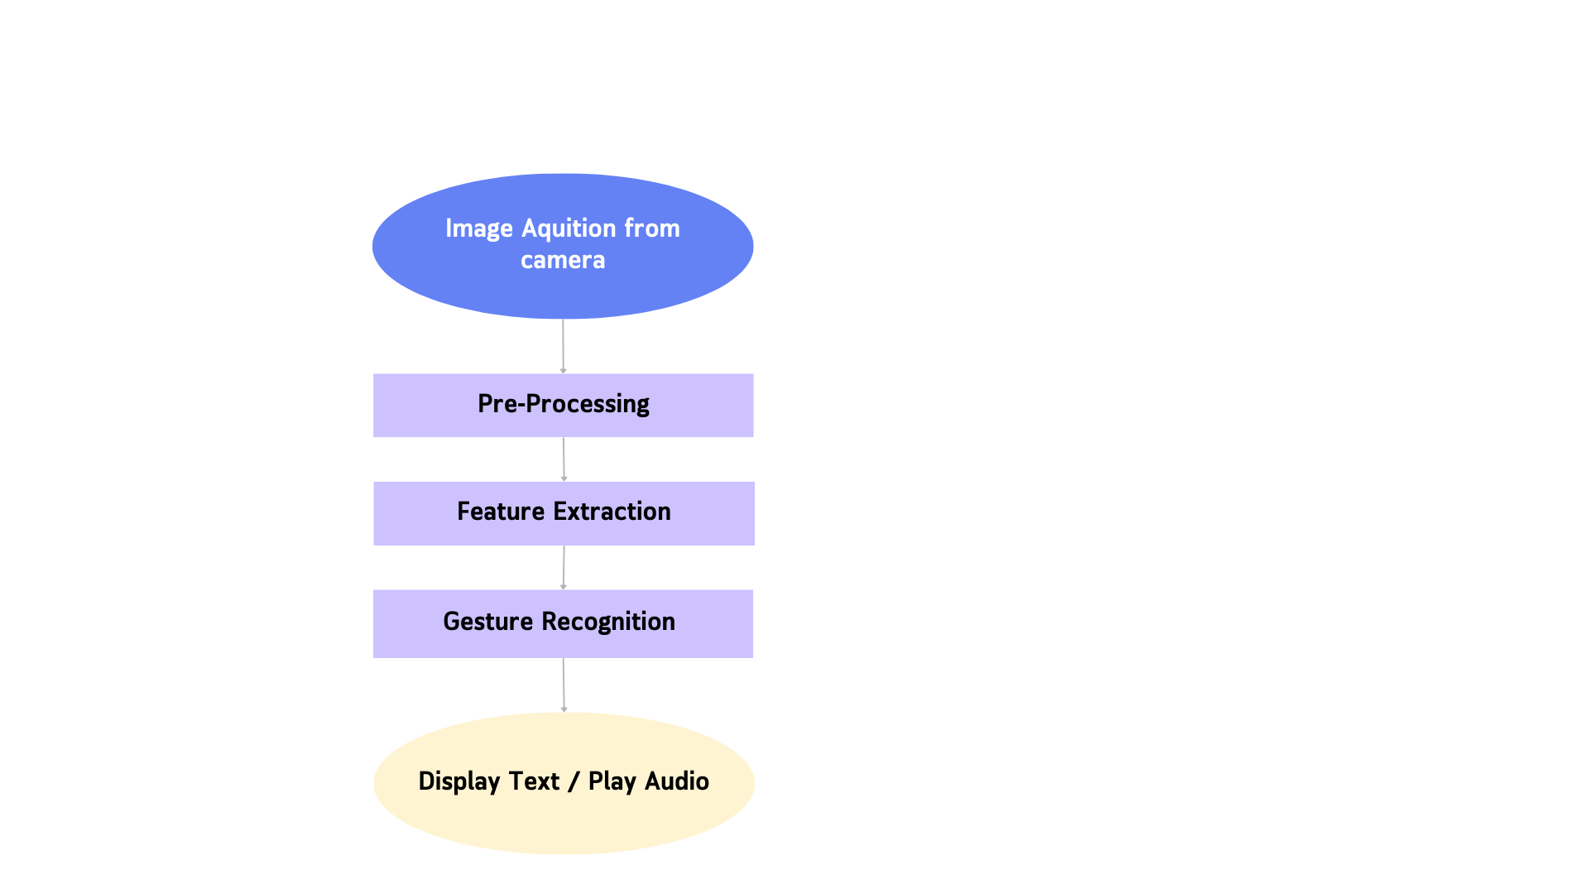**STEPS INVOLVED FOR SLC SYSTEM**

**METHODOLOGY:**

**OpenCV: -** OpenCV is a video and image processing library and it is used for image and video analysis, like facial detection, license photo editing, advanced robotic vision, and many more. This aims to recognize licence number plates. In order to detect license number plates, we will use OpenCV to identify number plates and then extract characters and digits from the number plates.

**KNN (K- Nearest Neighbours):-** KNN is one of the simplest forms of machine learning algorithms mostly used for classification. It classifies the data point on how its neighbor is classified. KNN classifies the new data points based on the similarity measure of the earlier stored data points.

**Image Processing: -** Image processing is a method to perform some operations on an image, in order to get an enhanced image or to extract some useful information from it. It is a type of signal processing in which input is an image and output may be image or characteristics/features associated with that image.

**SVM (Support Vector Machine):-** A support vector machine (SVM) is a supervised machine learning model that uses classification algorithms for two-group classification problems. After giving an SVM model set of labeled training data for each category, they're able to categorize new text.

**GrayScale: -** In digital images, grayscale means that the value of each pixel represents only the intensity information of the light. Such images typically display only the darkest black to the brightest white. In other words, the image contains only black, white, and gray colors, in which gray has multiple levels.

**OCR (Optical Character Recognition):-** Optical Character Recognition (OCR) is the conversion of images of handwritten or printed text into a machine text. There are several OCR engines. This system uses Tesseract - OCR engine. This can be downloaded in Anaconda using git. The segmented characters are given as input to OCR. The OCR will recognize those characters. The extracted data is stored in a data file or an excel sheet.

**FLOWCHART OF CNN**